Boombastics was established in July 2015, in a small café in the quaint village of Baile Bhlainséir, Dublin Ireland. It was founded as a small, family business by Rachel Egan Esq. BSc (almost), but quickly expanded. The company has established independent Programming, Graphics and Testing departments. Each member of the team have been educated and mentored by the top educators in the country.

Ryan Mackenzie CTO

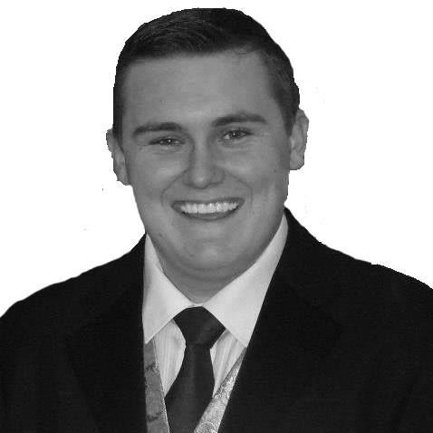

Ryan is a programming wizard (or so he thinks) who has an abundant supply of enthusiasm. He was a valuable member of the team once he learned to calm down a bit. He vision for the project was complimented by his willingness to negotiate on a daily basis. Boombastics love him.

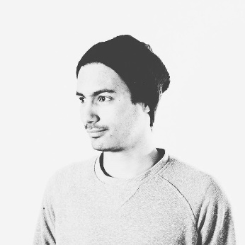Alcidemar Lopes De Araujo Netto TTO

This smokey little genius is only a temporary addition to the country. Originally from Brazil, Alcidemar was a late-comer to the project. After extensive interviews and police checks, we invited him to join Boombastics to enforce a stringent testing regime. Well, that was the plan. He contributed to the main program on several occasions but he was able to refocus on his own department. Ireland and Boombastics love him!!

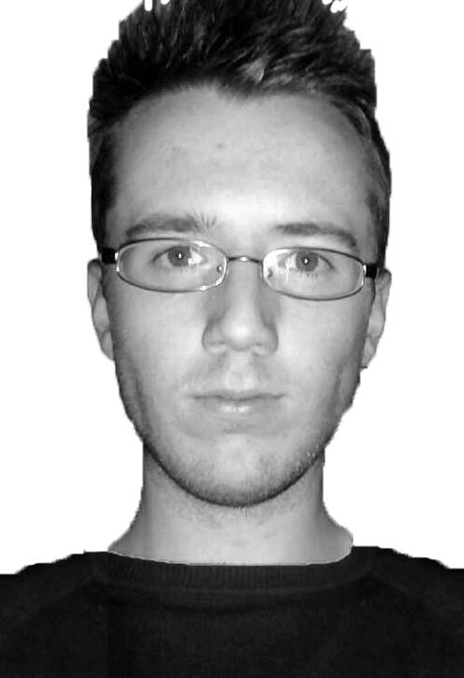

Darren Cosgrave CGO

Darren is a mysterious creature. Hard to pin down, but once captured, is a diligent and hard-working beast. He brought a lot to this project including the art of challenging the code, and button manipulation. With a keen eye for graphics (ehem!), Darren brought a lot to the GUI design and implementation whenever he was around. Boombastics love him.

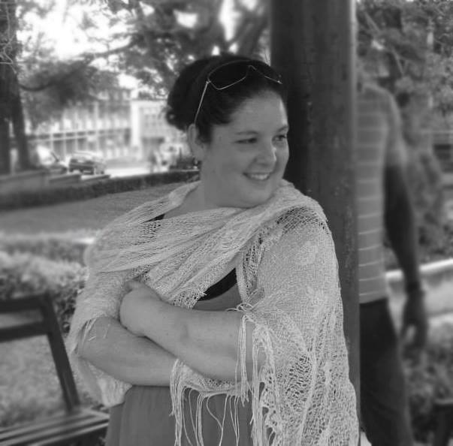

Rachel Egan CPO

Rachel brought a skill set similar to that of a famous German dictator, whose name escapes me at this time, overseeing project deadlines and being sure to help keep the team on track. Rachel's creative side came into play when designing the application in order for the best user experience. Rachel's constant blabbering of all the research she conducted aided greatly in not only the coding side of the project but the written also. Boombastics HATE her.